# *Web Programming I (420-C10-HR)*

# *Assignment 4 – Finished Website*

Date assigned: Monday, November 23, 2015

Date due: **Thursday, December 10, 2015**

**Learning Objectives**

Upon successful completion of this assignment, the student will be able to:

* Create a web page containing images
* Create a web page containing a form
* Create a web page containing a video
* Add meta tags to a web page
* Find a domain name for a web site
* Deploy a web site
* Test a deployed web site

To do:

1. Create a folder named YourUserName_C10_A04_Website. Copy all the folders for the web site developed in the last assignment into this folder.
2. Set up a site in Dreamweaver for the YourUserName_C10_A04_Website folder.
3. Change the name of the References page to be Testimonials and the References links in the template to link to Testimonials. Change the name of the Feedback page to be Inquiries and the Feedback links in the template to link to Inquiries.
4. On the Home page, add the following content in a paragraph, after the first paragraph, with relative links to the associated pages for the underlined words:

Our highly qualified staff is committed to the kennel’s mission of providing quality services for all pets. We offer flexible hours and competitive rates and you can read about what some of our satisfied customers have to say. If you have like further information about our services, please fill out our inquiries form. We also have links to other websites of interest to pet owners and a map and directions to our location are available for your convenience.

1. Add 2 dog images to the page, one floating to the right of the first paragraph and one floating to the left of the second paragraph. Create a new style rule for the text so that there is white space between the text and the images. Ensure that copyright rules are followed and that the images have been compressed for a web site.
2. On the Staff page, add the following content along with the photographs of the staff that were taken in the multimedia lab, using h1 for the heading, and a table for the photographs and the biographies. Ensure that the images have been compressed for a web site.

**Staff**

|  |  |
| --- | --- |
| Brent’s photo | Brent is responsible for booking your pet’s stay at Happy Valley Kennel and for keeping the office running. Brent has been with KVK since 2001 and has become a valued member of the team. Brent is also the proud owner of Grizzly, a Yorkshire Terrier. |
| Charlie’s photo | Charlie has been with Happy Valley Kennel for 10 years, and has worked in all areas of the business. He has always been passionate about animals and treats each pet as if it were his own.  Charlie has a pet cat named Angel. |
| Michelle’s photo | Michelle joined the staff at Happy Valley Kennel in the spring of 2004. She graduated from Algonquin College in 1990 and has many years of experience in boarding kennels. Her compassion and experience is evident as she cares for your pets. |
| Sam’s photo | Sam is in his first year at Heritage College in the Science program, in preparation for university, where he plans to study veterinary medicine. He works at HVK on weekends and after school.  Sam is responsible for taking care of your pets while they are here in boarding, as well as making sure the facility is clean inside and out. |

1. On the Testimonials page, add the following or similar content, using h1 for the heading, and the formatting as show below, using a new style in the style sheet:

**Testimonials**

“***Happy Valley Kennel*** *is very clean and well maintained and the service is always friendly and professional. Most importantly for us, it is the first kennel our pets have actually enjoyed going to!”* Mario & Nancy, Gatineau, QC

“*We can’t say enough about the staff and facilities at* ***Happy Valley Kennel****. We are so impressed with the professionalism and quality of service.”* Rebecca & James, Ottawa, ON

*“I was so excited when I discovered* ***Happy Valley Kennel****. Jim & Sally and their staff are the best! My dog is always happy to stay there and it’s close to home.”* Margery, Chelsea, QC

Include following the text, the video that was completed in the multimedia lab, and the format and size of the video (so that visitors to the web site know what to expect). Add an appropriate image as a poster for the video.

1. On the Inquiries page, add the following content, using h1 for the heading, a form with the controls specified below. Use CSS with fieldgroups to format your form. Fieldgroups must, at least, be included around the check boxes, but can be included to group other fields together. Make sure that labels are aligned to the right and that the fields have different lengths depending on how long you think the field would be.

**Inquiries**

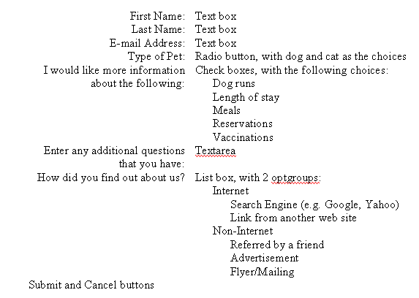

1. On the Contact page, add the following content, using h1 for the heading, and a table to organize the information.

**Contact**

For reservations and inquiries, please call our office during operating hours or fill out the inquiries form. Please note that we do not accept online reservations at this time.

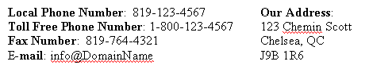

Change the words “operating hours” to be a link to the Hours page and the words “inquiries form” to be a link to the Inquiries page. Change the e-mail address to be a link and make sure the domain matches the domain you choose for your site (more below).

1. Add at least 5 meta tags that can be used to increase the possibility of the web site being found by search engines. Add the tags to the template.
2. Choose an appropriate domain name for the web site. Check for its availability. When you have found an appropriate domain name that is available, include the domain name in header section of the web page and in the e-mail address in the Contact page.
3. Make sure your site works properly on mobile devices. The site should only include the limited information as detailed in the previous assignment.
4. Validate your site for both HTML5 and CSS3. When your site is valid, include the “valid icons” at the bottom of your home page (see the bottom of the CSS validation page when you have successfully validated for the required code).
5. Deploy your web site to the csdev web server (your O drive). Name the folder hvk and, if required, rename the home page to be index.html. The url for your deployed site should be http://csdev.cegep-heritage.qc.ca/students/yourusername/hvk/index.html.
6. Test your web site (both on screen and on mobile) to ensure the following:

* No Broken Links.  All links are checked and work.
* No Broken Images.  All images work.
* All pages use "jpg" or "gif" or “png” image files, not "bmp," or "psd" files.
* Every page includes a Copyright notice.  For example, © 2013 Happy Valley Kennel. All Rights Reserved.
* Each page contains "text links" to central pages on the website.
* Each page has a link back to the site's Home Page and main topics pages.
* Each page has "Alt tags" for all central images. You don't really need Alt tags for horizontal bars or tiny bullet gifs.
* Each page uses either a "1024 by 768" or “1280 x 1024” layout. If you use a "1280 x 1024" layout, you must put a warning on the top of the webpage that it is best viewed in this format.
* Each page has a title that tells the user what its larger goal is.
* Each page uses an invisible table and layers to layout the page's grid.
* Each page uses the basic principles of alignment to layout text, images, and graphics on a page. The material should not be thrown on the page, but laid out according to a larger grid strategy.
* A website should include a set of linked pages that go together based on a larger theme. A website isn't just one web page.

Source: <http://www.colorado.edu/AmStudies/lewis/Design/basicele.htm>

1. Make sure that you do not have any embedded or inline styles in the page.

**To submit**

When you have completed the assignment, zip the YourUserName_C10_A04_Pages folder containing the following documents to the C10 and load them to Moodle:

* All the files in the web site.